Corporate Servers
College of Science, Engineering, and Technology, Grand Canyon University
ITT-216: Enterprise Route & Switch
Instructor Tim Collins
Liela Pressley
4/30/2023
- Added a DNS and WWW Server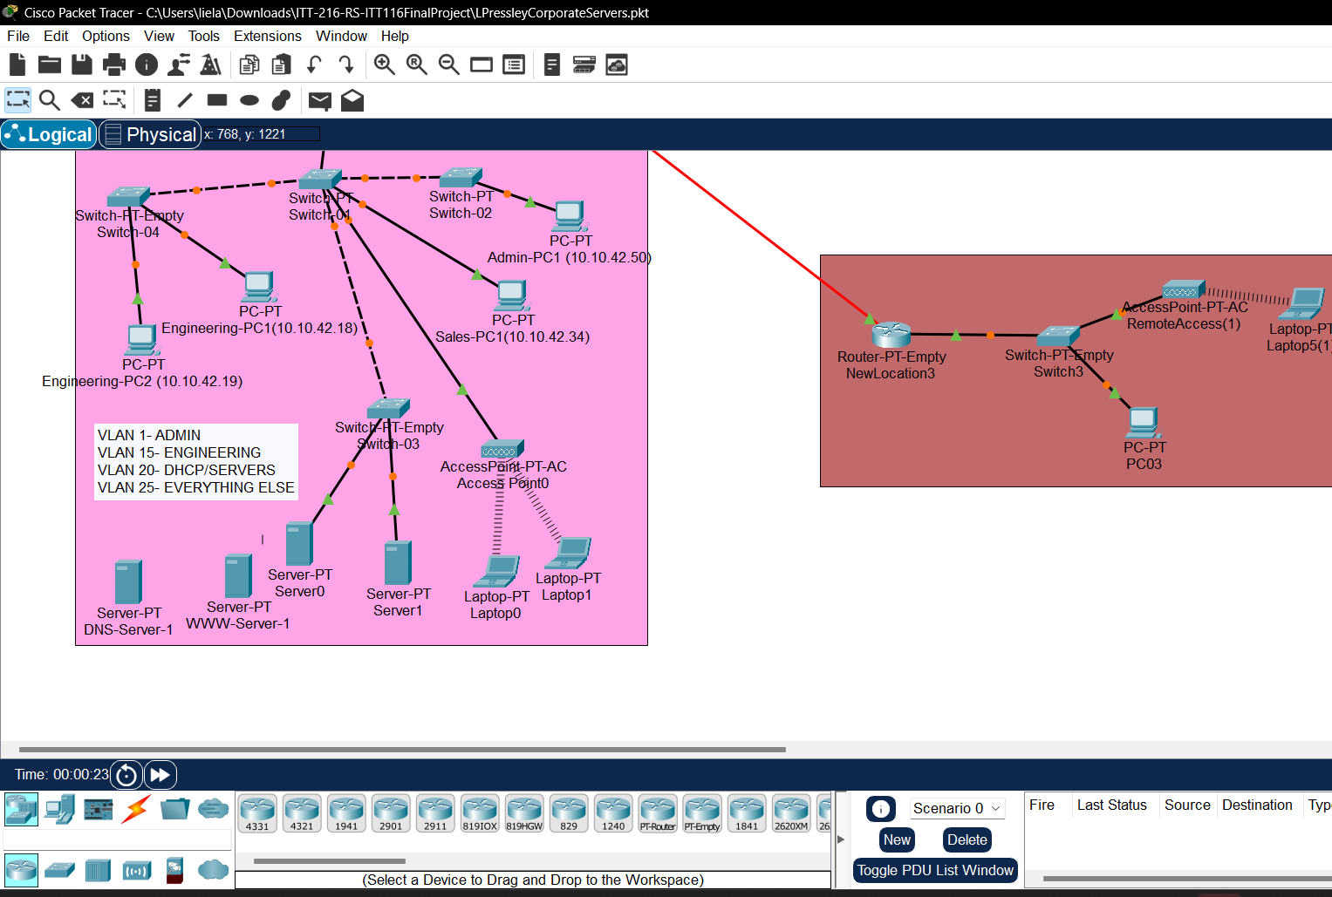
- Configured the default gateway to 10.10.42.81 and static IP to 10.10.42.86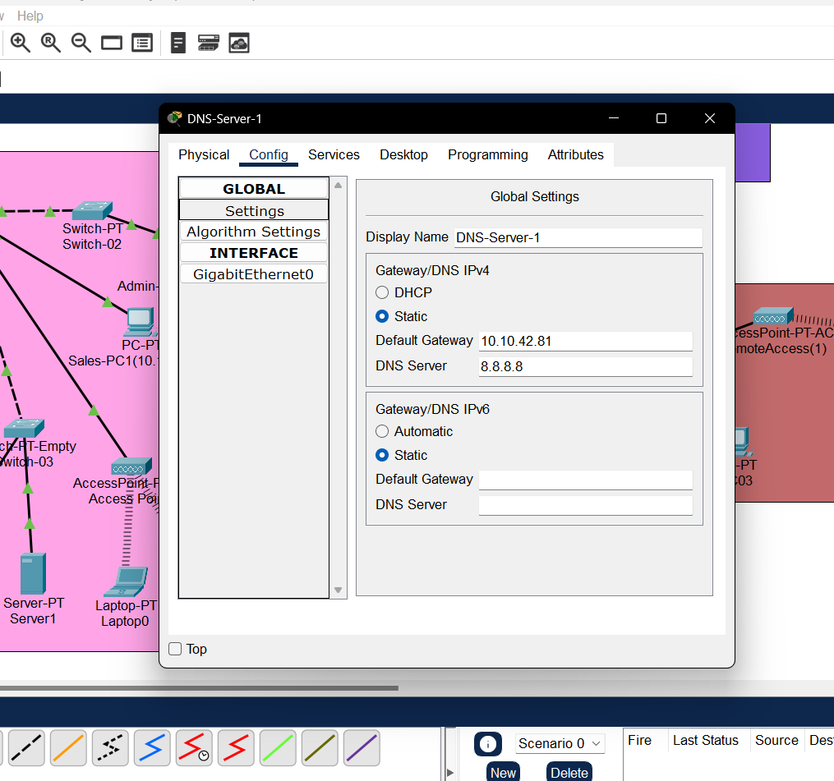
- Inputting DNS records dhcpserver1-wwwserver1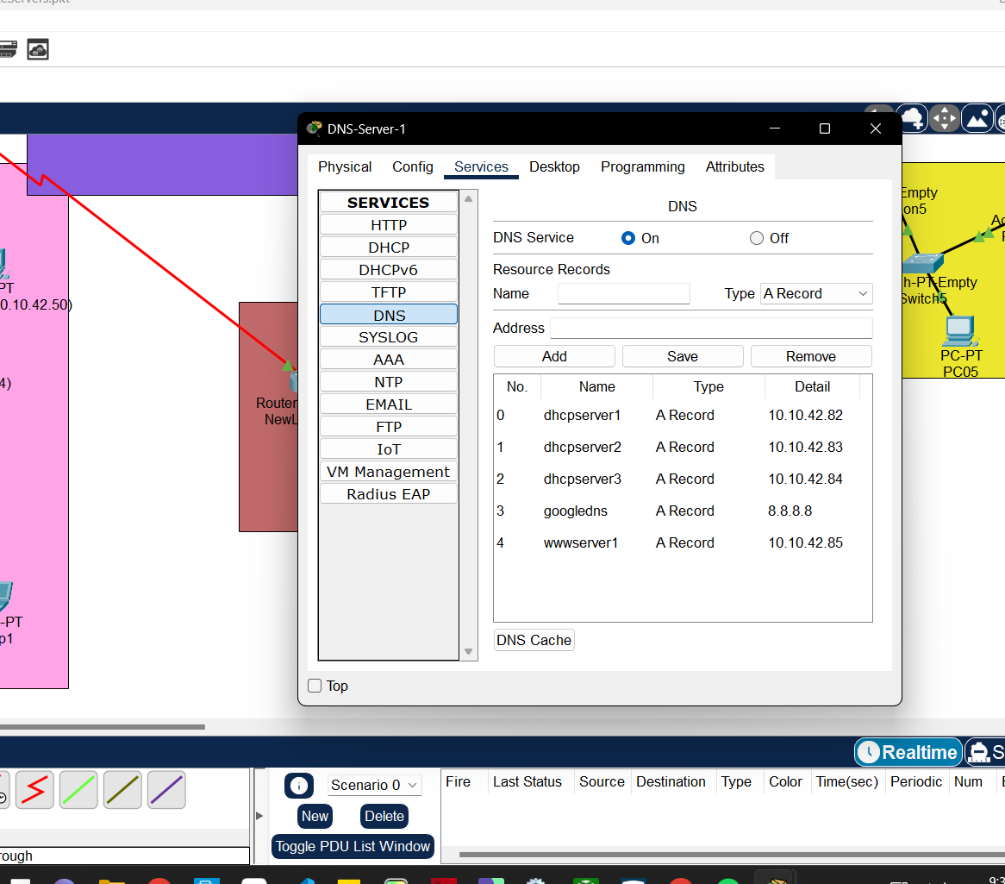
- Configured WWW server’s gateway and connecting to DNS server etc.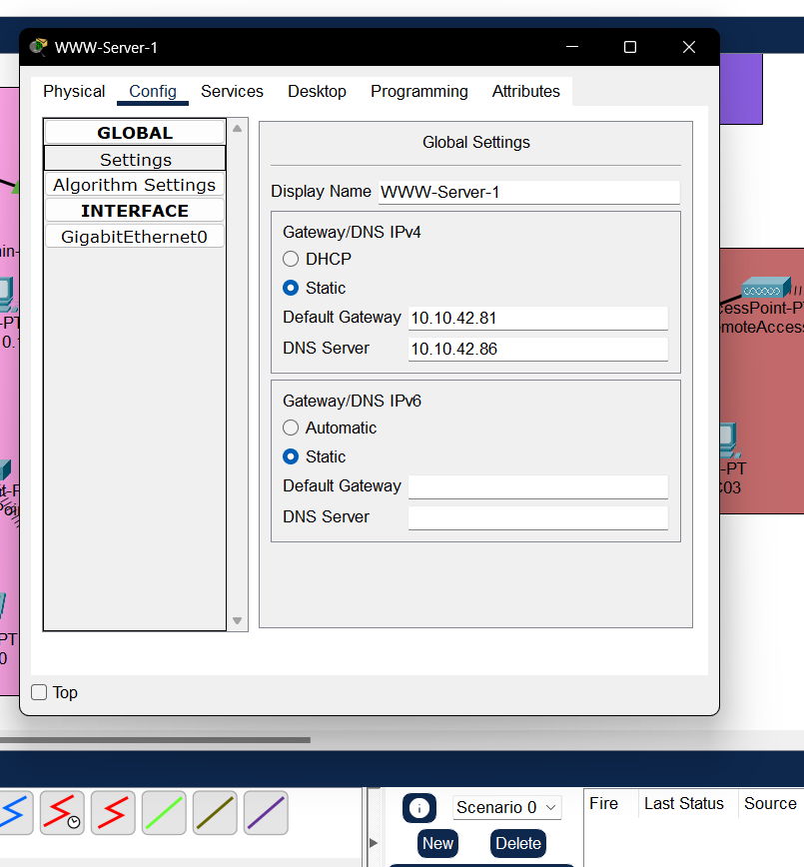
- Successfully pinging the DNS server and the WWW server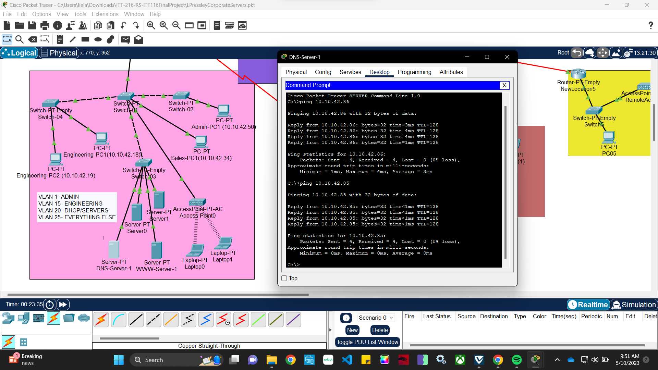
- Configure the DHCP service on the server to connect to the DNS server updated ip address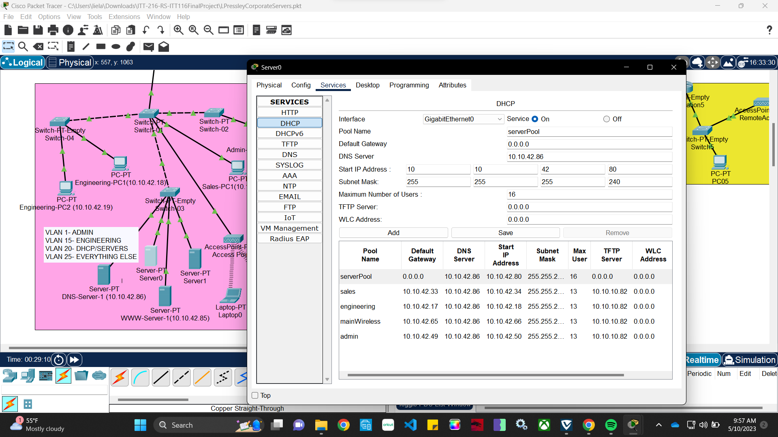
- Configure DHCP service on server1 to connect to DNS server to update IP address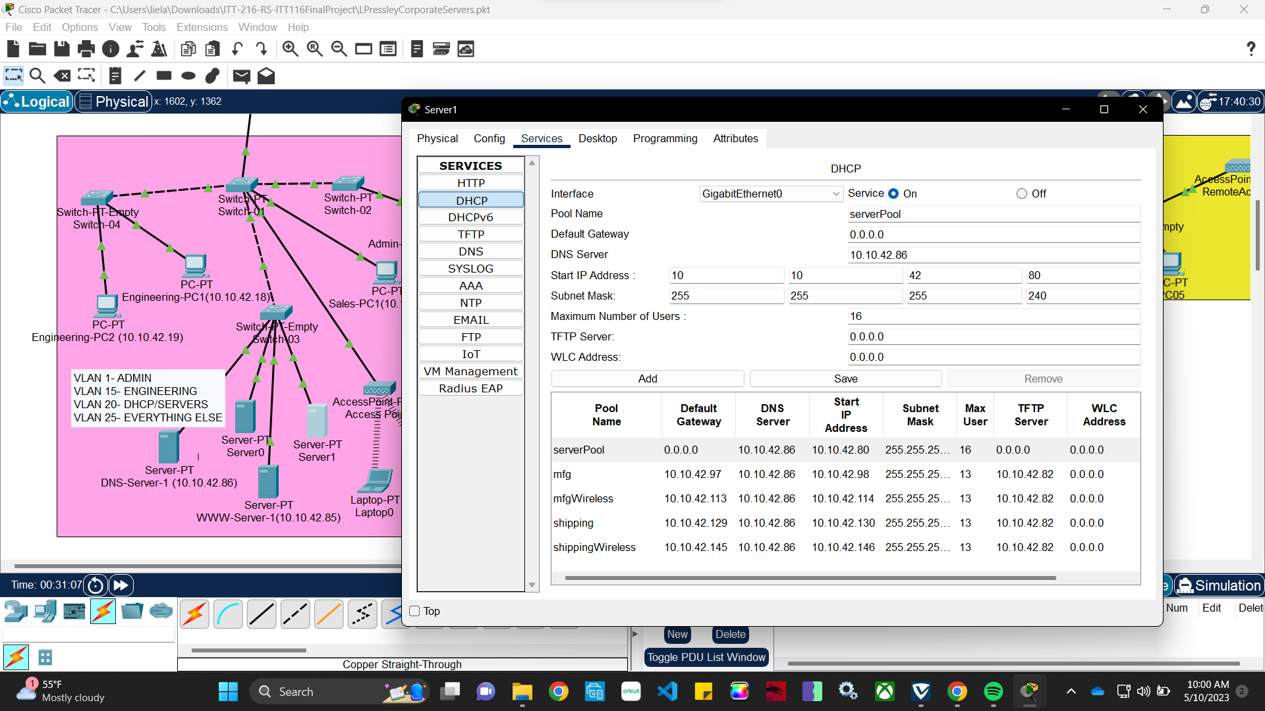
- Checked to see if the PC on the network can recongize/successfully see the newly configured/added DNS server 